Assignment-4
- Check Even/Odd and Positive/Negative .Take a number and determine whether it is positive /negative/zero and ,if applicable ,whether it is even or odd.

Code:
import java.util.Scanner;

public class EvenOdd {
public static void main (String[] args) {

Scanner sc = new Scanner (System.in);

System.out.println("Enter a number: ");
int num = sc.nextInt();

if (num > 0)
System.out.println("Positive number");
else if (num < 0)
System.out.println("Negative number");
else
System.out.println("Zero");

if (num % 2 == 0)
System.out.println("Even number");
else
System.out.println("Odd number");

sc.close();
}
}

Output:
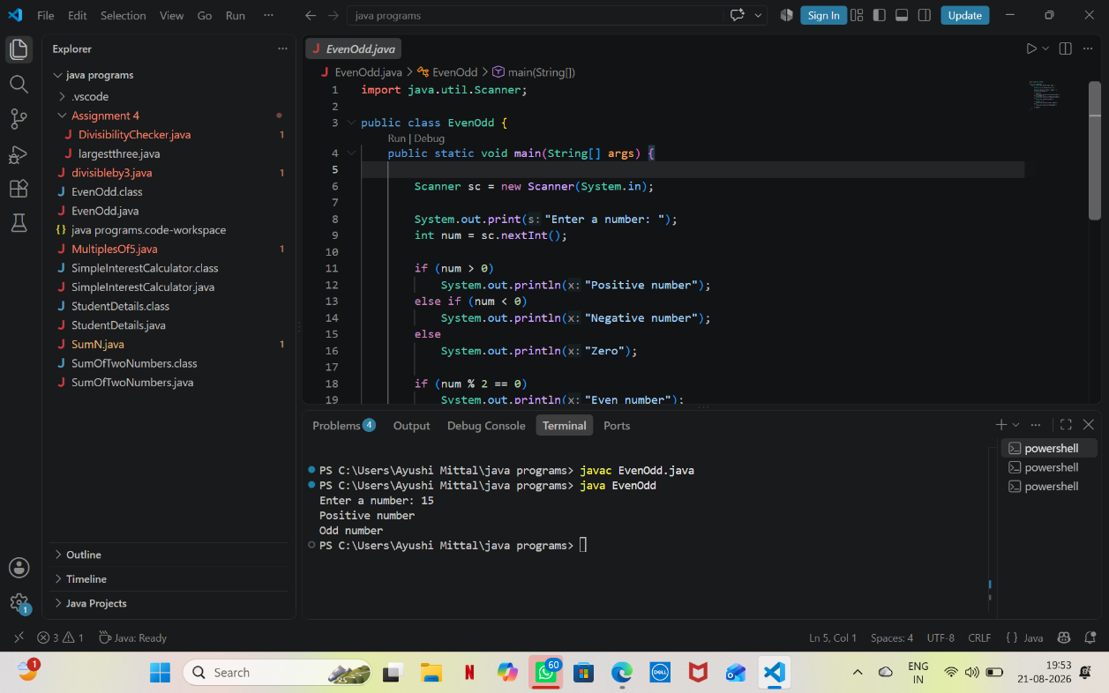

- Largest of three numbers .take three numbers and find the largest using if-else.

Code:
import java.util.Scanner;

public class largestthree {

public static void main(String[] args) {

Scanner sc = new Scanner(System.in);

System.out.println("Enter three numbers:");

int a = sc.nextInt();
int b = sc.nextInt();
int c = sc.nextInt();

if (a >= b && a >= c)
System.out.println("Largest = " + a);
else if (b >= a && b >= c)
System.out.println("Largest = " + b);
else
System.out.println("Largest = " + c);

sc.close();
}
}

OUTPUT:
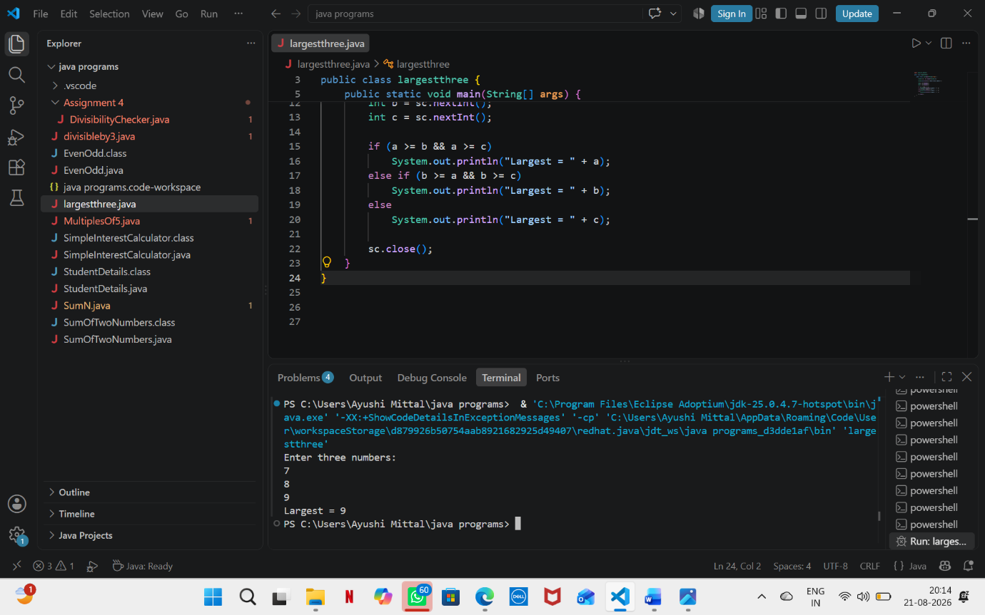

- Number Divisibility Checker
CODE:
import java.util.Scanner;

public class DivisibilityChecker {
public static void main(String[] args) {

Scanner sc = new Scanner(System.in);

System.out.print("Enter a number: ");
int num = sc.nextInt();

if (num % 5 == 0) {
System.out.println("The number is divisible by 5.");

if (num % 10 == 0)
System.out.println("The number is also divisible by 10.");
else
System.out.println("The number is not divisible by 10.");
} else {
System.out.println("The number is not divisible by 5.");
}

sc.close();
}
}

OUTPUT:
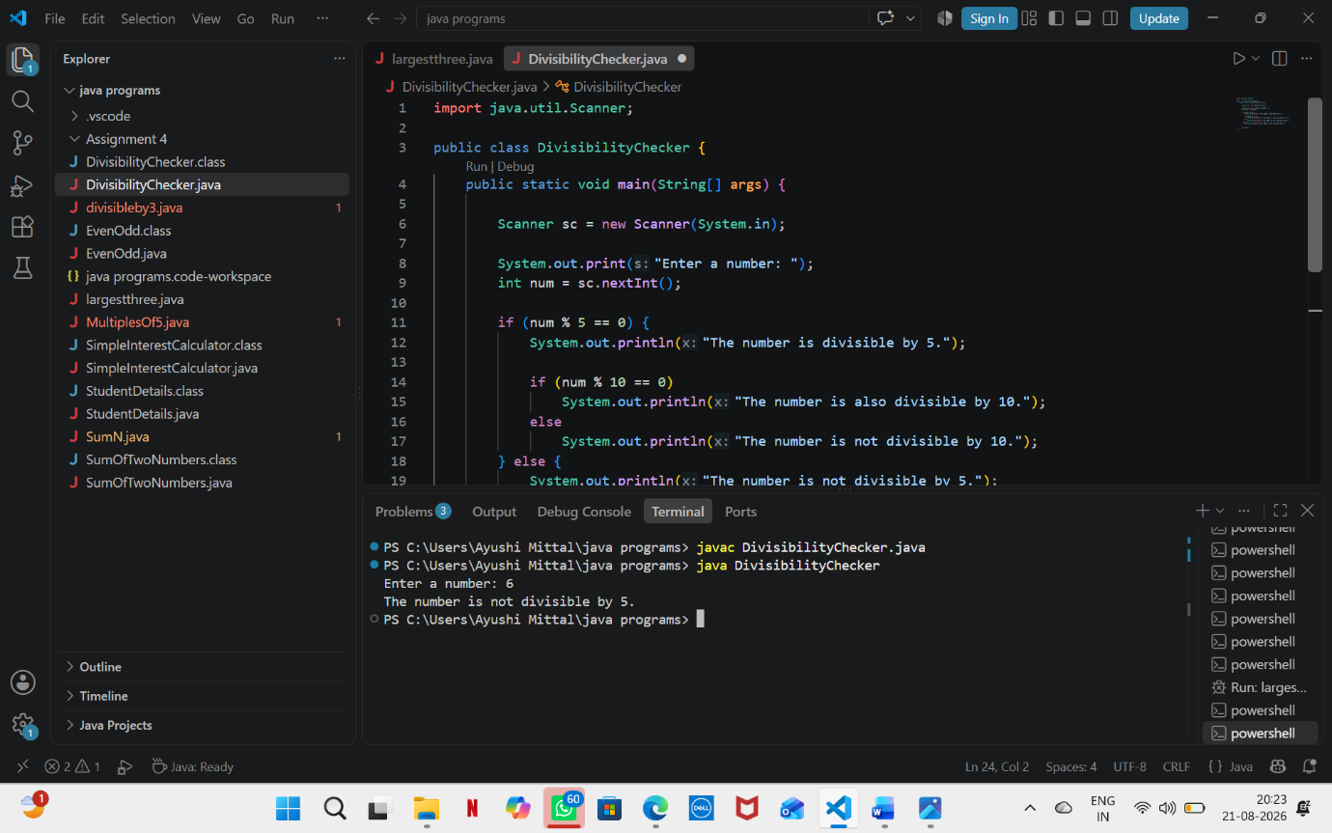

- Check Working Day
Code:
import java.util.Scanner;

public class DivisibilityChecker {
public static void main(String[] args) {

Scanner sc = new Scanner(System.in);

System.out.print("Enter a number: ");
int num = sc.nextInt();

if (num % 5 == 0) {
System.out.println("The number is divisible by 5.");

if (num % 10 == 0)
System.out.println("The number is also divisible by 10.");
else
System.out.println("The number is not divisible by 10.");
} else {
System.out.println("The number is not divisible by 5.");
}

sc.close();
}
}

OUTPUT:
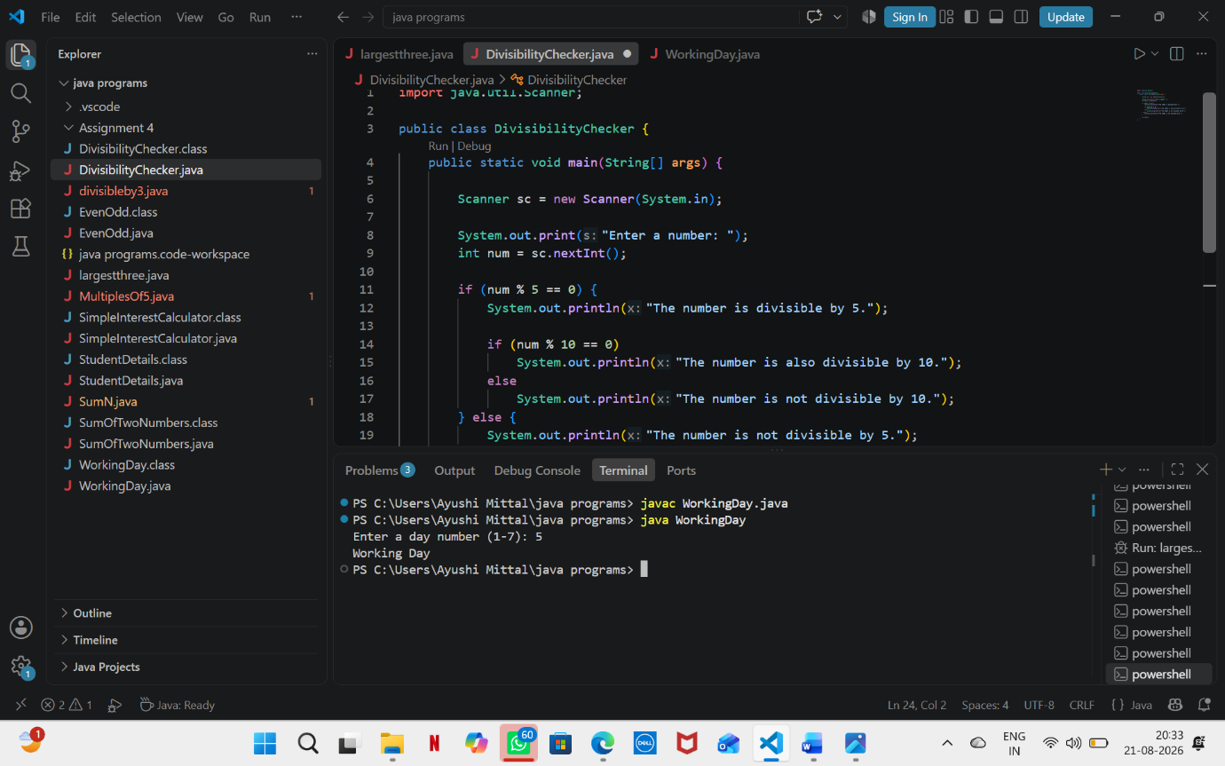

- Password Length Checker
Code:
import java.util.Scanner;

public class PasswordChecker {
public static void main(String[] args) {

Scanner sc = new Scanner(System.in);

System.out.print("Enter password: ");
String password = sc.nextLine();

int length = password.length();

if (length < 8)
System.out.println("Password is Weak.");
else if (length <= 12)
System.out.println("Password is Acceptable.");
else
System.out.println("Password is Strong.");
sc.close();
}
}

OUTPUT:
